Los Shipping Re-Initialization for AVUATSQL-CL02 (WHS-S8MP-UADB1) to WHS-S3MS-UADB3

* Make sure fire wall is open between two servers
* Make sure the recovery mode of publisher database is in bulk logged/full mode

1. Database size on principle server is 65 GB and file structure is below

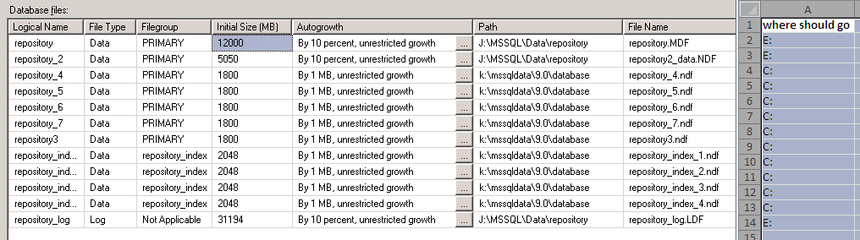

1. Subscriber server (WHS-S3MS-UADB3) has 124 GB space (no need to shrink data)
2. Take the full backup of the Repository database on AVUATSQL-CL02
3. Copy that backup file to the WHS-S3MS-UADB3
4. Restore the database backup as RepositoryDR database using following query
5. Open a light speed console on AVUATSQL-CL02
6. Register both servers (publisher and subscriber)
7. Use restore wizard and create script to restore “RepositoryDR” database

Backup:

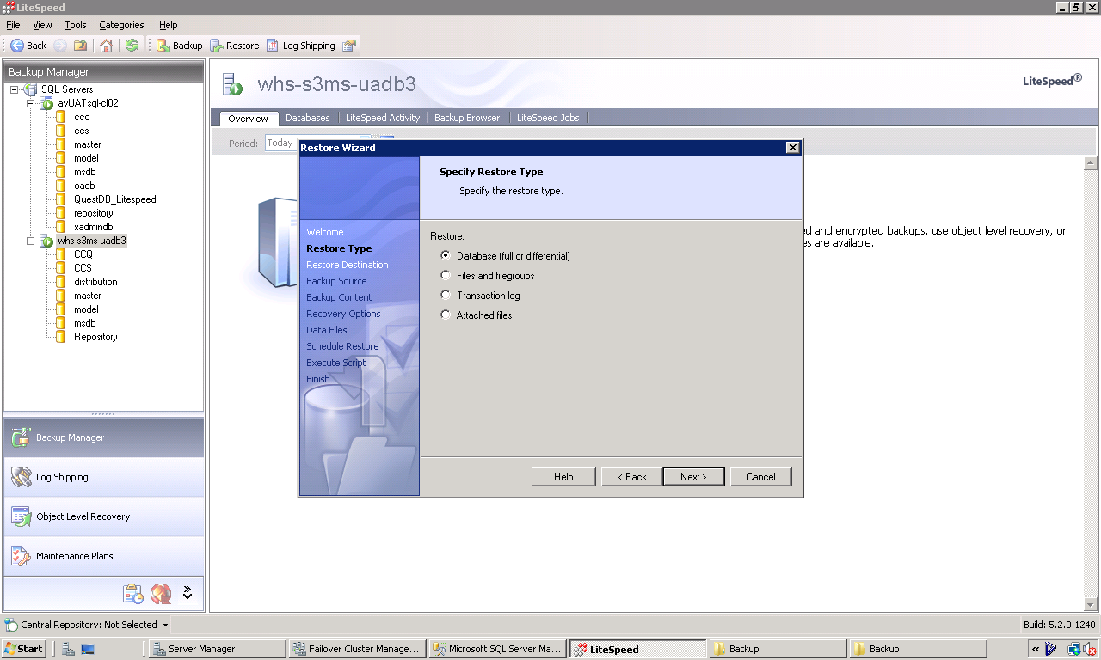

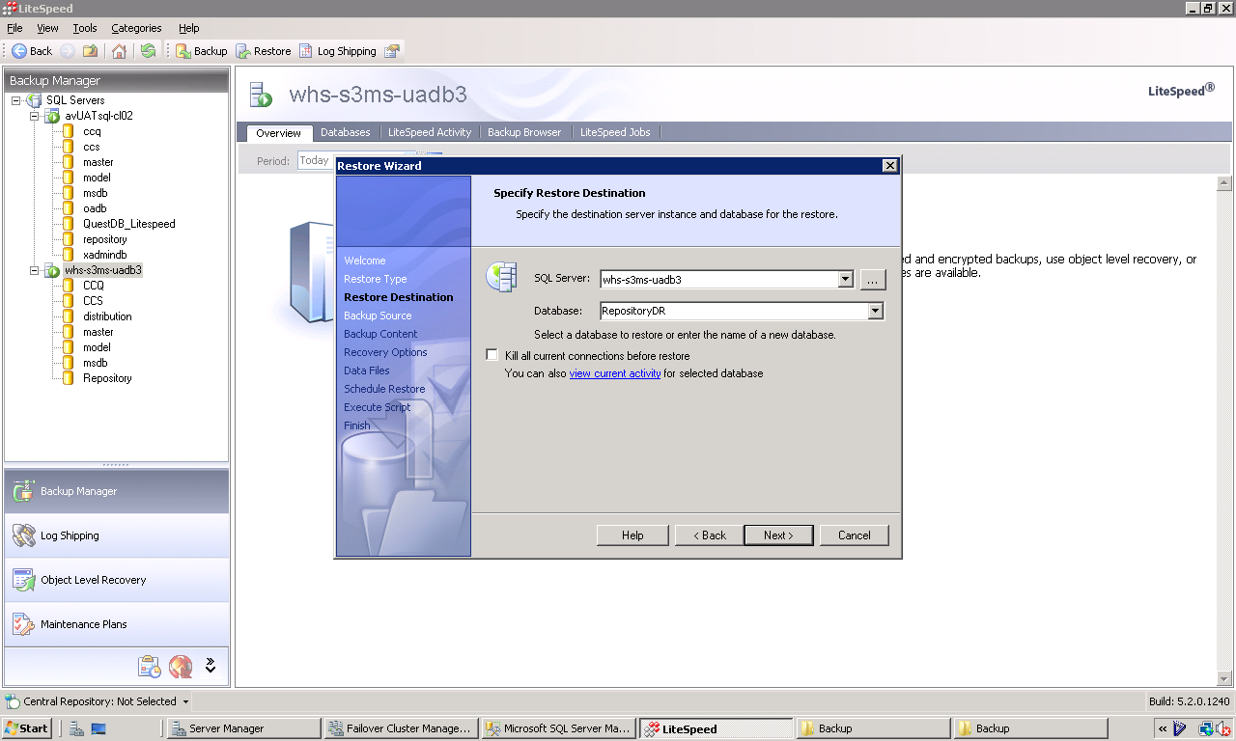

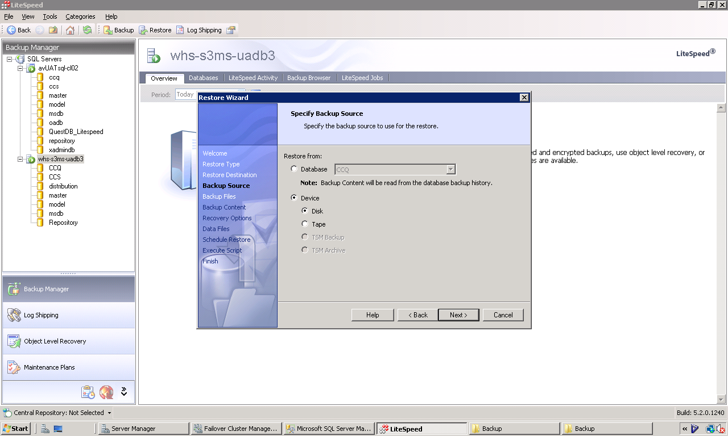

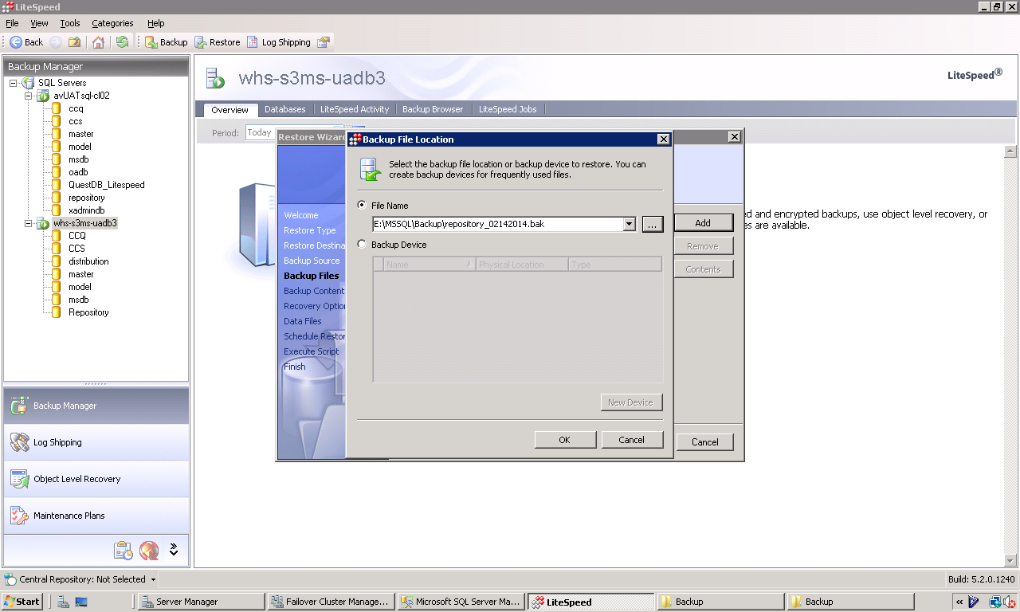

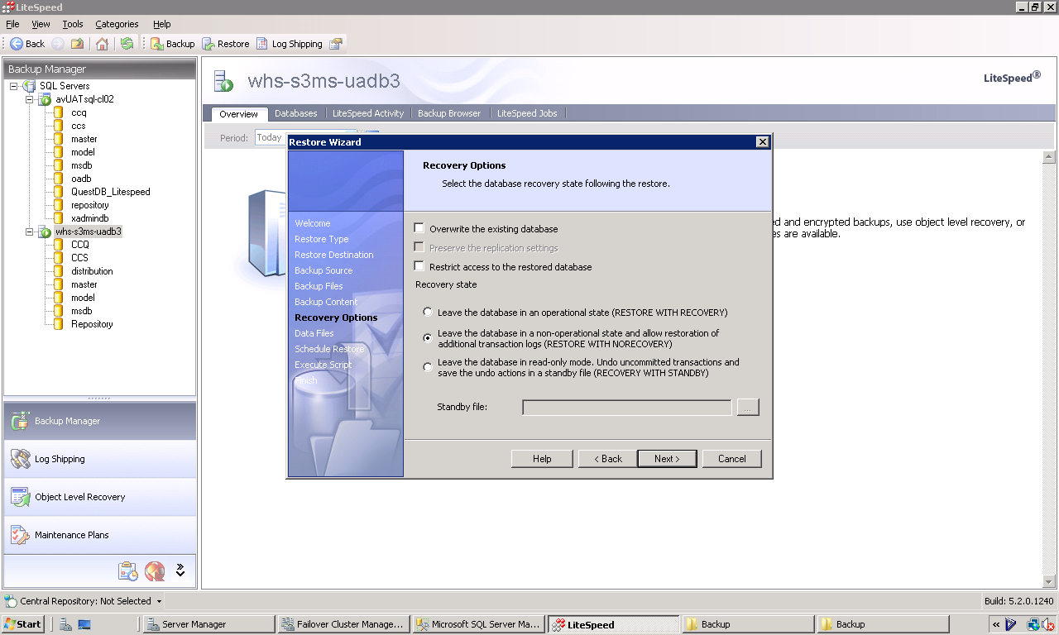

f